Entry Task: Consider the tank shown.
The height is 3m, the width at the top is 2m and the length is 6m. We are pumping the water up to 4m above the ground out of a spout.
Water has a density of 1000 kg/m³.

If it starts full, how much work is done to pump it all out?

If you don’t know how, that is fine, then instead do this…
- Label y = 0 and a typical y
- Label a horizontal slice at y.
- For that slice…
  - Find a formula for the width.
  - Find a formula for the volume.
  - Find a formula for the mass and weight.

6.4 Work (continued)

Recap: Constant force and given distance:
Work = Force·Distance
If force or distance change
$$Work=\lim_{n→∞}{\sum_{i=1}^{n}{(Force · Dist)}}=\int_{a}^{b}{(Force)(Dist)}$$

PROBLEM TYPE 1 (“Leaky Bucket”):
An single object is lifted, but gets lighter (or heavier) as it is lifted.
FORCE = f(x_{i}),
DIST = ∆x

PROBLEM TYPE 2 (“Stack of Books”)
A bunch of objects are stacked up and each gets lifted a different distance.
FORCE = (density)(horiz. slice length or vol)
DIST = depends on labels
(typically $x$ or $a-y$)

Old Exam Problems:
Set up the integrals that give…
1. A rocket loses mass as it burns fuel. The mass of the rocket when it is x meters off the ground is given by
$f\left(x\right)=\frac{40}{9.8}+\frac{20}{9.8}e^{-\frac{x}{2}} kg$.
Set up the integral for the work done in the first 8 meters after launch.

2. A 50 foot cable with density 4 lbs/ft is hanging over the side of a tall building. Find the total work done in lifting the cable halfway up.

3. (Fall ‘17 exam) The figure shows a tank.
The front face of the tank has the shape: $f(x) = 4x^{2}$. Initially, there is fluid in the tank up to a height of 1 foot. The fluid weighs 15 lb/ft³. How much work is done to empty the tank by pumping all of the fluid to the top of the tank?

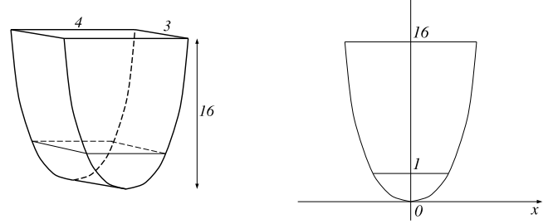

6.5 Average Value
The average y-value of y = f(x) from
x = a to x = b is given by
$$f_{ave}=\frac{1}{b-a}\int_{a}^{b}{f\left(x\right)dx}$$

Example: The formula for the temperature of a particular object is T(t) = t² degrees Fahrenheit where t is in hours. Find the average temp. from t = 1 to t = 4 hours.

Mean Value Theorem for integrals:
If f(x) is continuous on from x = a to x = b, then there is at least one value x = c at which
f(c) = f_{ave}.
Example:
Using T(t) = t² from t = 1 to t = 4 again.
Find a time at which the temperature is exactly equal to the average value.

Derivation:
The average value of the n numbers:
y₁, y₂, y₃, …, y_{n}
is given by
$\frac{y_{1}+y_{2}+y_{3}+⋯+y_{n}}{n}=y_{1}\frac{1}{n}+⋯+y_{n}\frac{1}{n}$.

Goal: We want the average value of all the y-values of some function
y = f(x) over an interval x = a to x = b.

Derivation:
- Break into n equal subdivisions
$∆x=\frac{b-a}{n}$, which means $\frac{∆x}{b-a}=\frac{1}{n}$

- Compute y-value at each tick mark
$$y_{1}=f\left(x_{1}\right), y_{2}=f\left(x_{2}\right),…,y_{n}=f\left(x_{n}\right)$$

- Ave $≈f\left(x_{1}\right)\frac{∆x}{b-a}+⋯+f\left(x_{n}\right)\frac{∆x}{b-a}$
$$Average ≈\frac{1}{b-a}\sum_{i=1}^{n}{f\left(x_{i}\right)∆x}$$

Thus, we can define
$$Average=\frac{1}{b-a}\lim_{n→∞}{\sum_{i=1}^{n}{f\left(x_{i}\right)∆x}}$$
which means the exact average y-value of y = f(x) over x = a to x = b is
$$f_{ave}=\frac{1}{b-a}\int_{a}^{b}{f\left(x\right)dx}$$

